Verzeo Minor Project-Back end web-dev Node.js

Name: N. Aadityaa

Project Name: Mongo DB with Node.js minor project

Project Deadline: 20/04/2022

Project statement: Create a Node.js file that reads the HTML file, and return the content in local server. Use Node.js File System Module to read HTML file.HTML file should contain some content.

i.e.

• Headings

• Paragraphs

• List Items etc.

Project Link: <https://drive.google.com/drive/folders/1nQ9ykY4rmmvTYl1TYfDNQi8IxNou7e4y?usp=sharing>

JavaScript file:

<https://drive.google.com/file/d/1AwnOuN-PkIs0fKJFr9UH8UexTmM9T7As/view?usp=sharing>

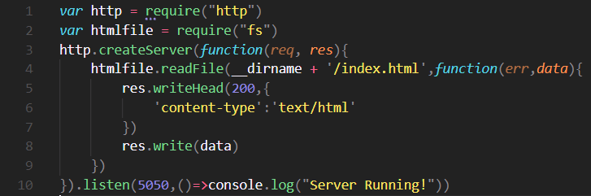

HTML file:

<https://drive.google.com/file/d/1IACP77ajYYEjptteZKPJojNKeNTB0Qeu/view?usp=sharing>

<!DOCTYPE *html*>

<html *lang*="en">

<head>

  <meta *charset*="UTF-8" />

  <meta *http-equiv*="X-UA-Compatible" *content*="IE=edge" />

  <meta *name*="viewport" *content*="width=device-width, initial-scale=1.0" />

  <title>😇Aadityaa's personal website</title>

</head>

<body>

  <table>

    <tr>

      <td>

        <h1>Aadityaa</h1>

        <p>

          <em><strong>VIT</strong> Chennai fresher</em>

        </p>

        <p>

          I'm a fresher at <em><strong>VIT</strong></em> Chennai in the CS

          department this is my first personal website😇

        </p>

      </td>

    </tr>

  </table>

  <hr *size*="2" *nonshade* *color*="blue" />

  <h3>Education🎓</h3>

  <ul *class*="bigger" *style*="font-family: 'Lucida Sans', 'Lucida Sans Regular', 'Lucida Grande', 'Lucida Sans Unicode', Geneva, Verdana, sans-serif;">

    <li><em><a *href*="http://siddharthvillageschool.in/">Siddhart village school</a>'</em>19 -->Primary school</li>

    <li><em><a *href*="http://sishyaschool.edu.in/">Sishya school</a>'</em>21 -->high school</li>

    <li><em><a *href*="https://chennai.vit.ac.in/">VIT C</a>'</em>25 -->college

  </ul>

  <hr *size*="2" *nonshade* *color*="blue" />

  <h3>Skills📃</h3>

  <table *border*="1" *style*="font-family: 'Lucida Sans', 'Lucida Sans Regular', 'Lucida Grande', 'Lucida Sans Unicode', Geneva, Verdana, sans-serif;">

    <header>

      <th>Languages</th>

      <th>Knowledge Level</th>

    </header>

    <body>

      <tr>

        <td>Python</td>

        <td>★★★★☆</td>

      </tr>

      <tr>

        <td>Java</td>

        <td>★★☆☆☆</td>

      </tr>

      <tr>

        <td>HTML</td>

        <td>★☆☆☆☆</td>

      </tr>

      <tr>

        <td>Flutter</td>

        <td>★☆☆☆☆</td>

      </tr>

    </body>

  </table>

  <hr *size*="2" *nonshade* *color*="blue" />

  <form *id*="form">

    <p>How is my website?</p>

    <input *type*="radio" *id*="ok" *name*="rating">

    <label *for*="ok">Okish</label><br>

    <input *type*="radio" *id*="gd" *name*="rating">

    <label *for*="gd">Good</label><br>

    <input *type*="radio" *id*="awsm" *name*="rating">

    <label *for*="awsm">Awesome</label>

    <div><button *type*="submit">Submit</button></div>

  </form>

  <a>--by N.AADITYAA🤞</a>

</body>

</html>

Output:

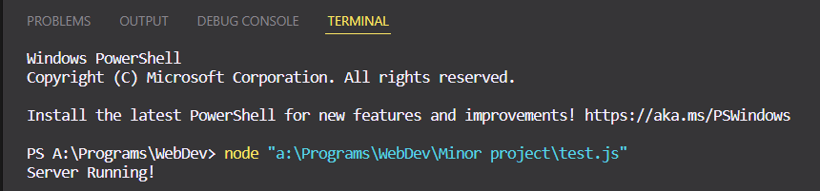

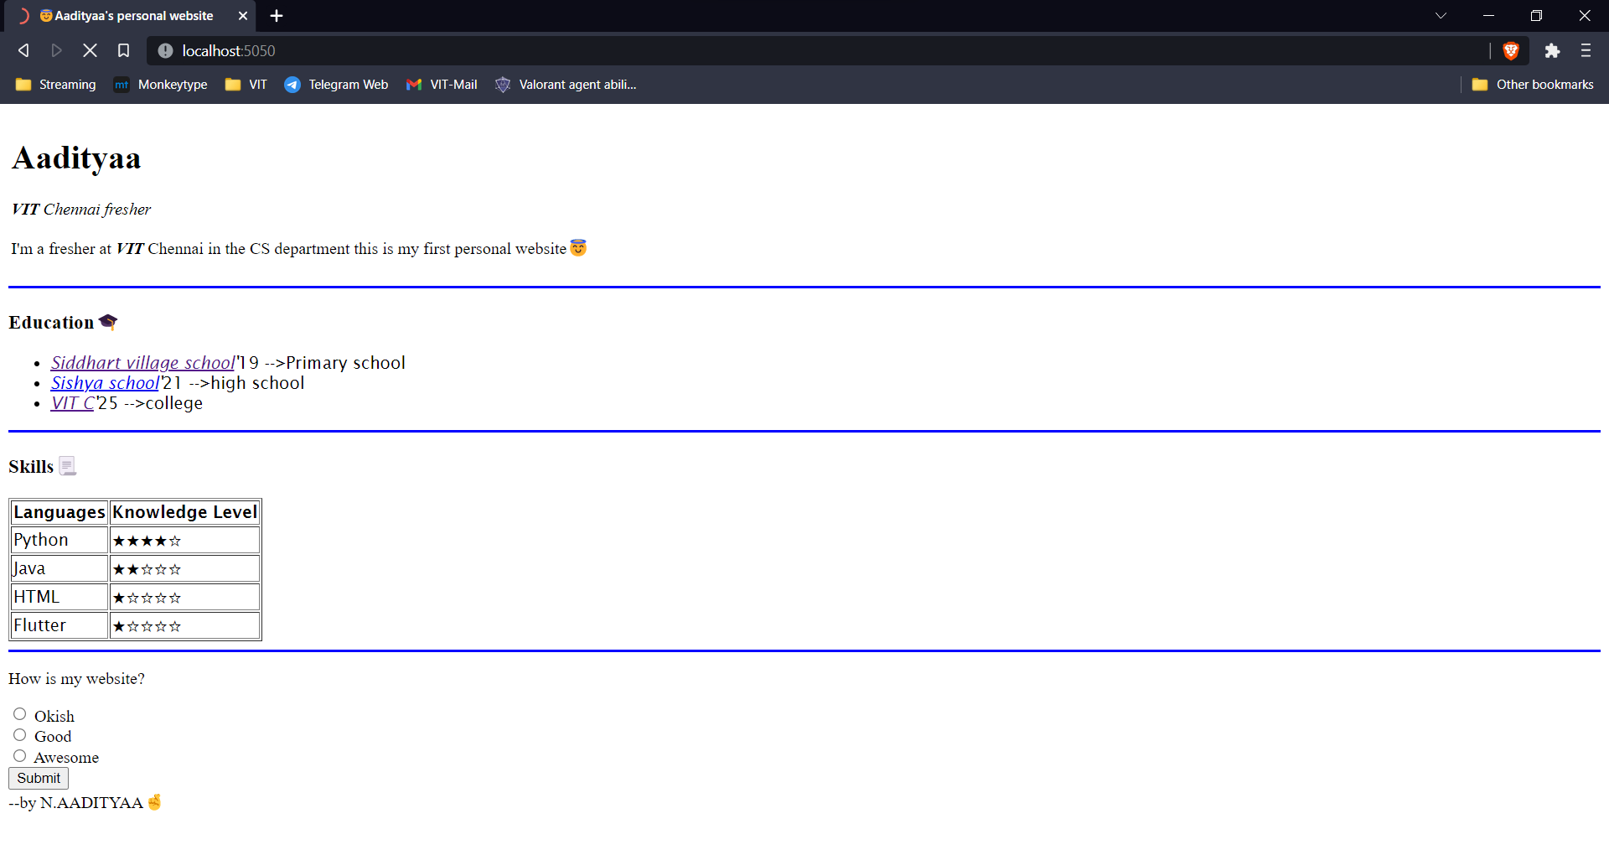

Thank you

-By N. Aadityaa